**Software Engineering Tools Lab**

**PRN:2019BTECS00022**

**Name: Prachi R. Chobhare**

**Batch: T3**

**Assignment No-3**

(Module 3- GitHub) **Due date-23/02/2022**

Q 1. Create a repository on GitHub named SET Lab and add files into it (you can add implementation files of previous assignment) perform below operations on it. (Add screenshot as an answer to every question)

**Solution: I am using Previous Assignment is assignment no 2 : implementation of linear regression by using dataset. Now, I am creating a repository on Github…**

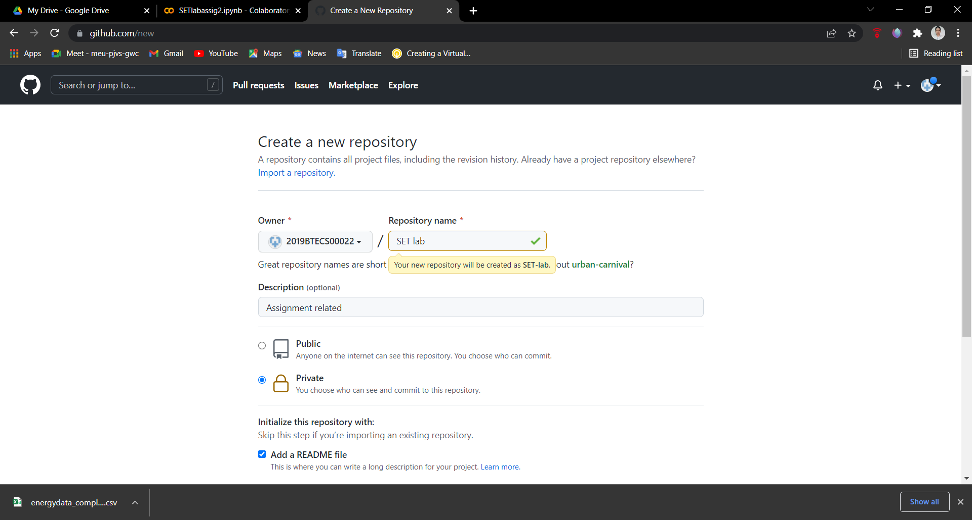

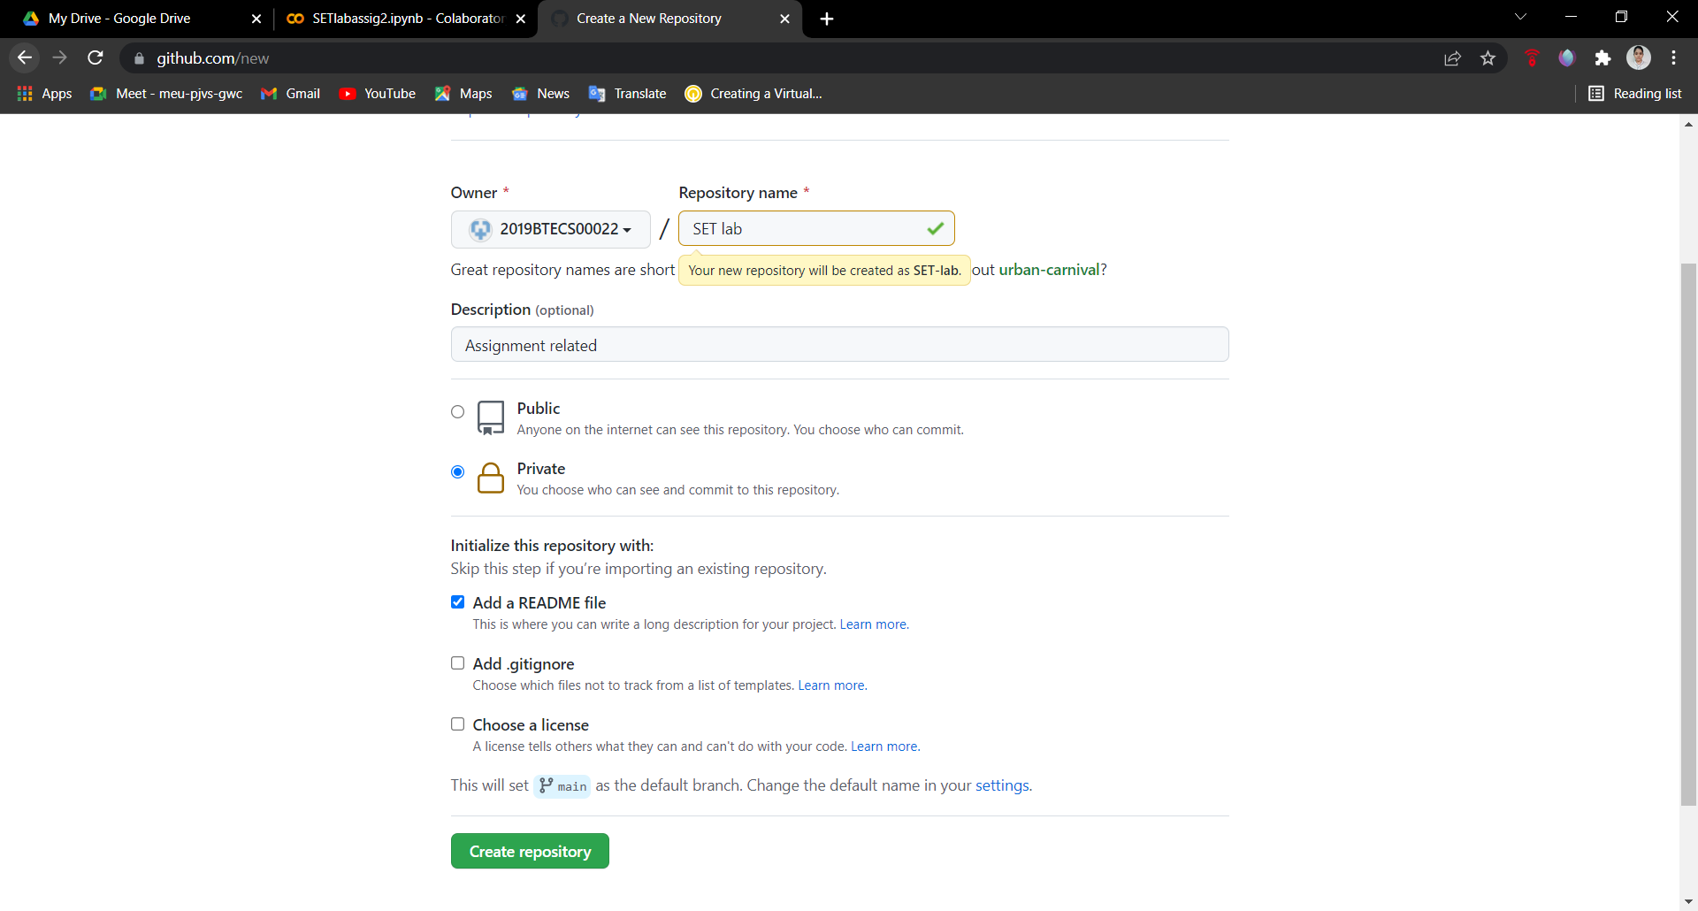

**So basically I make mistake here, that is to make SET lab repository is public so for that, after creating repository go to repository setting and Under the Danger zone click change visibility and do some changes and enter and your repository will be public.**

1. Perform commit on added files

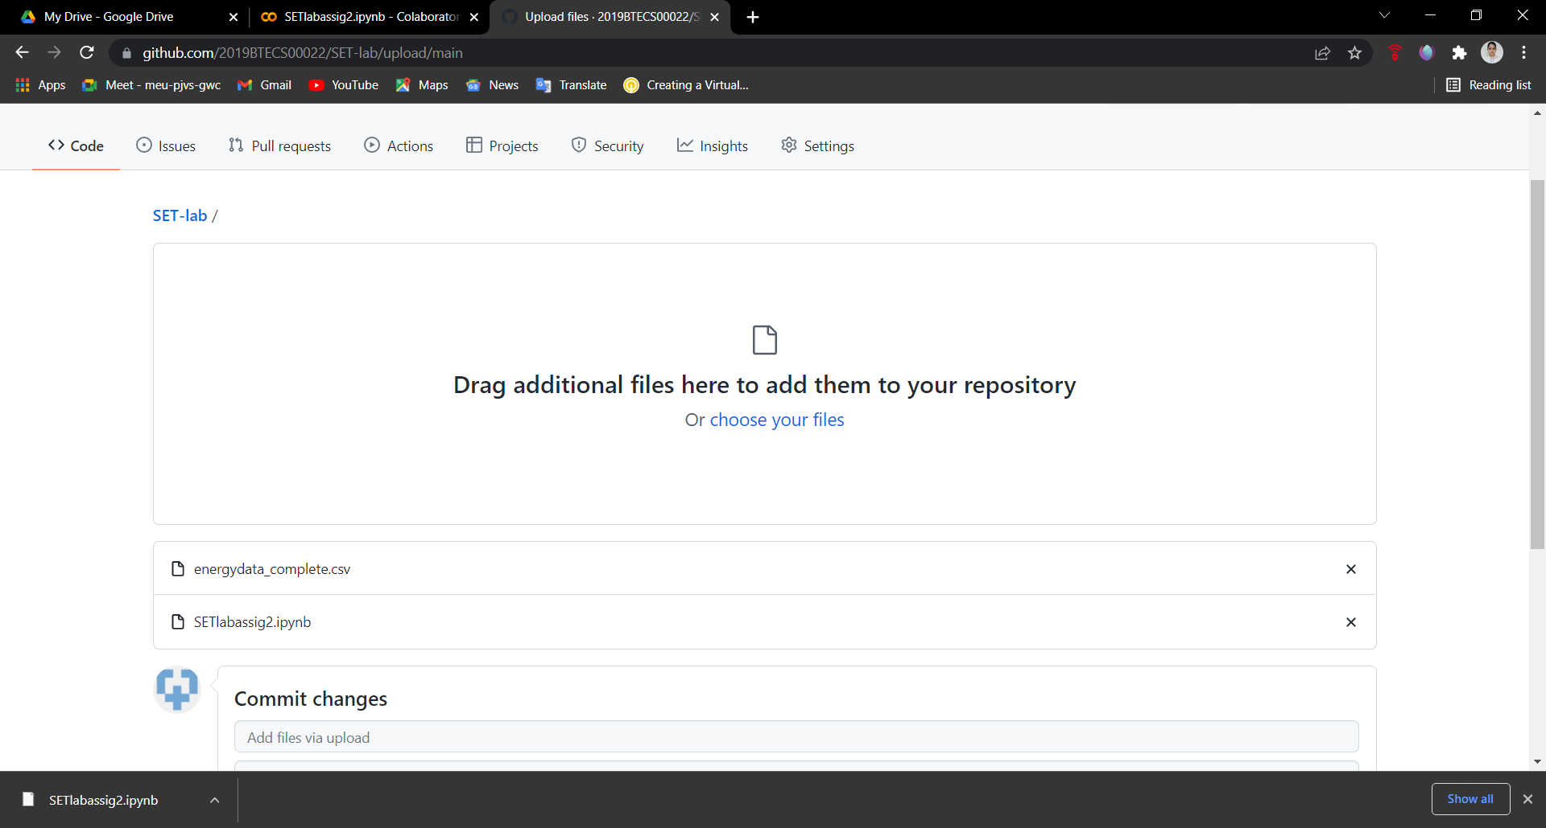

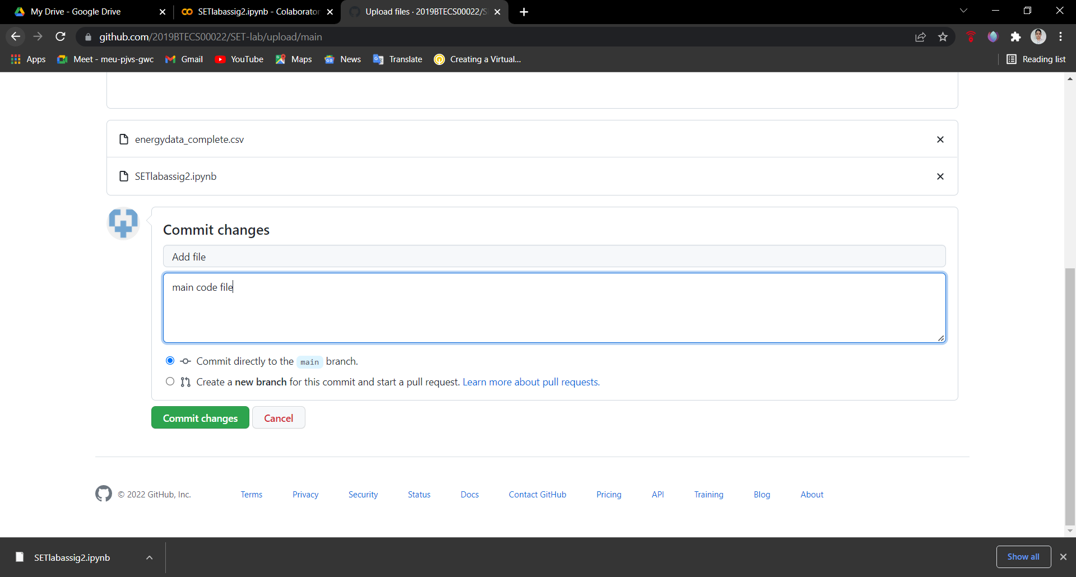

1. Perform update to the existing files (show history)

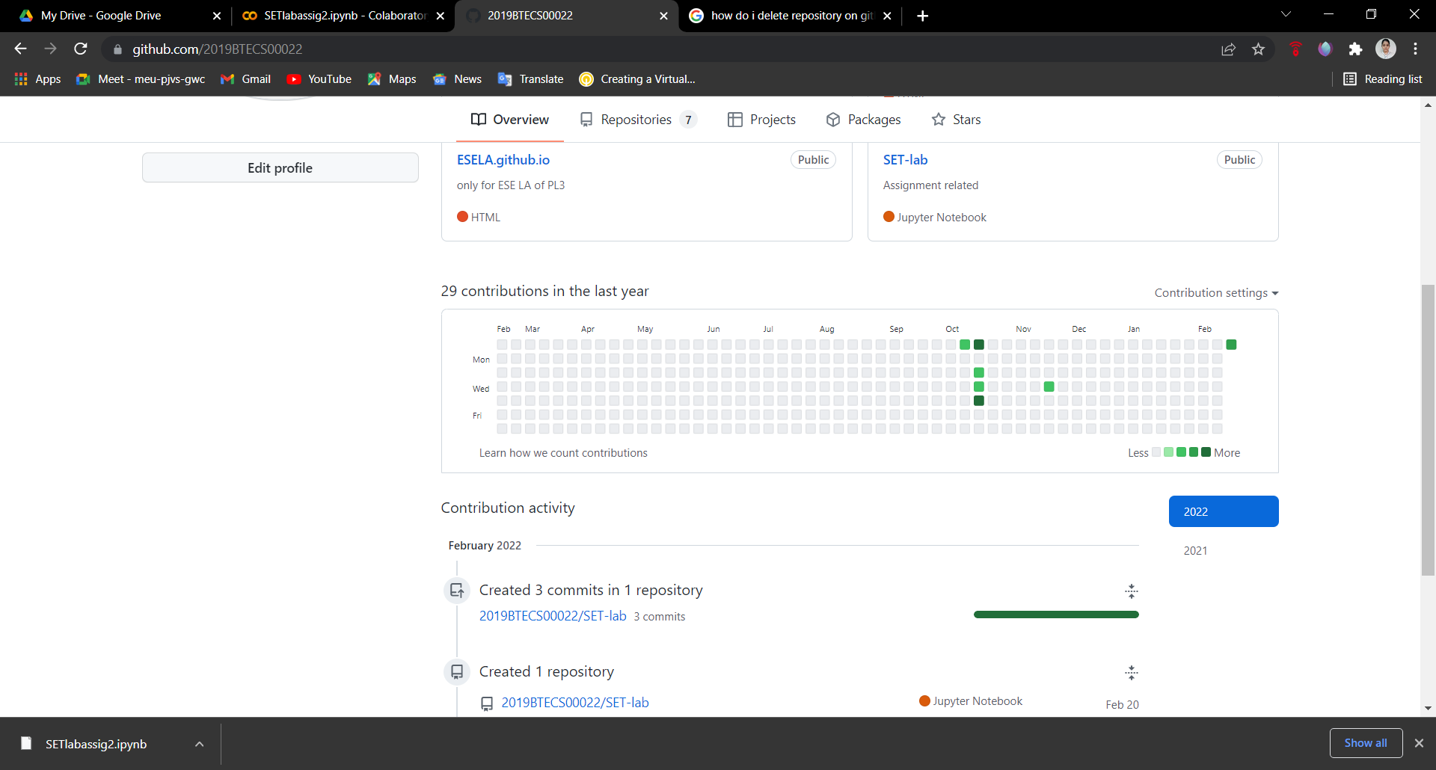

1. Create another branch

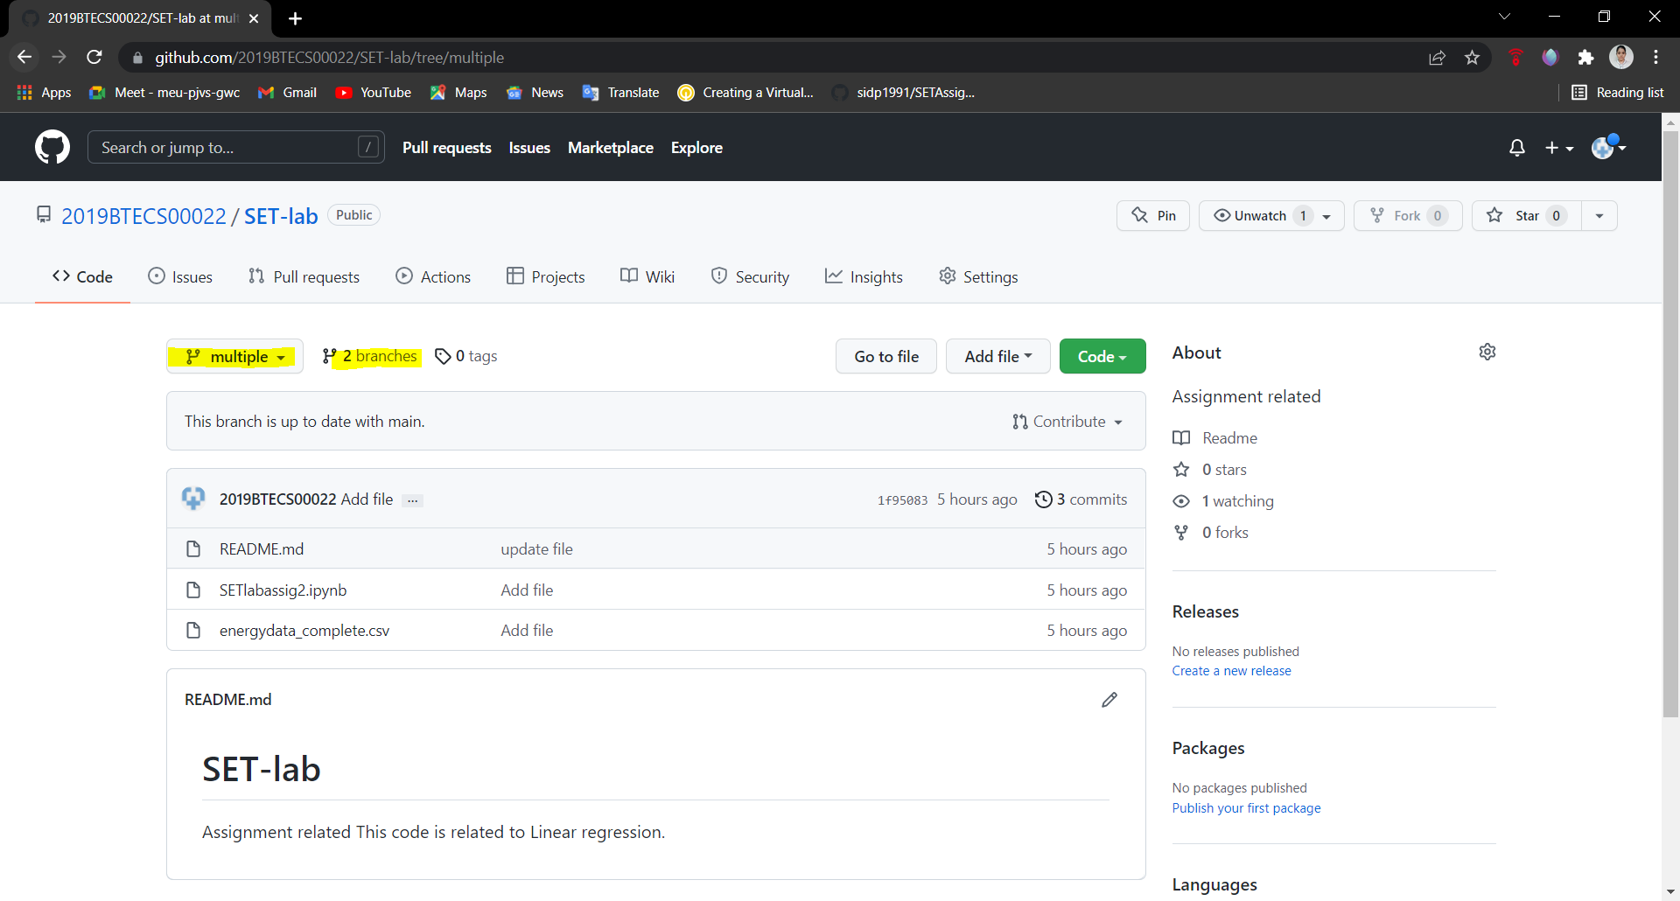

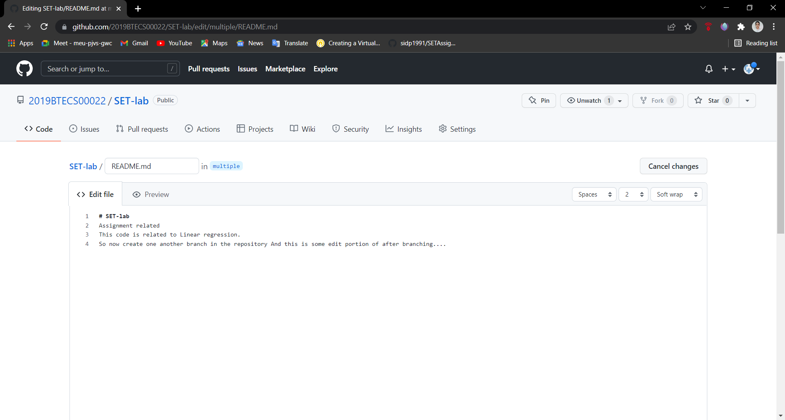

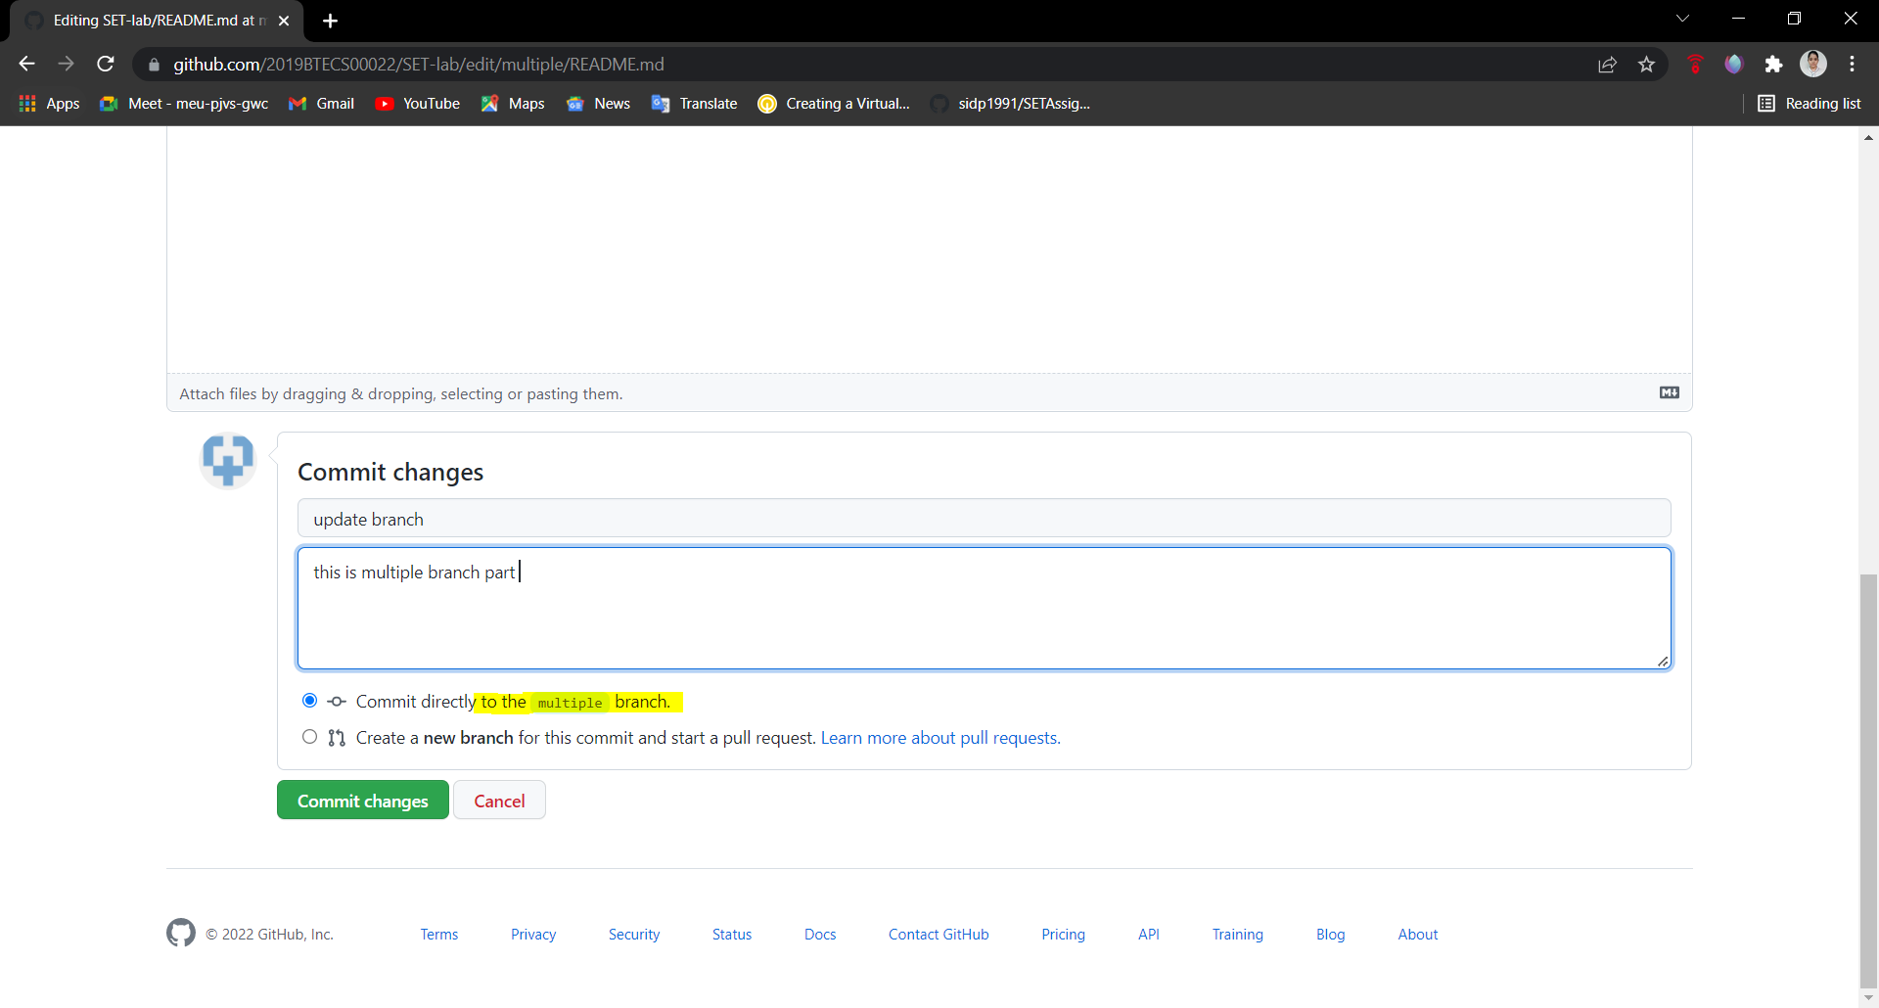

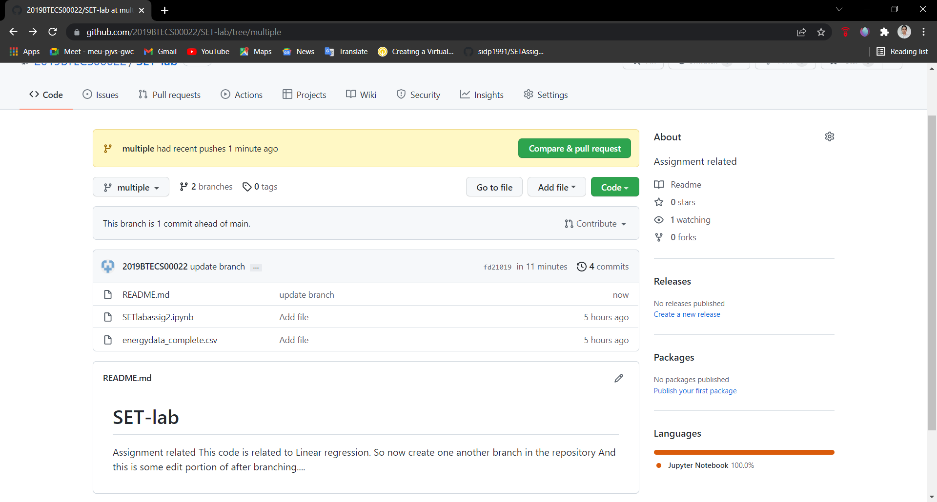

1. Create pull request

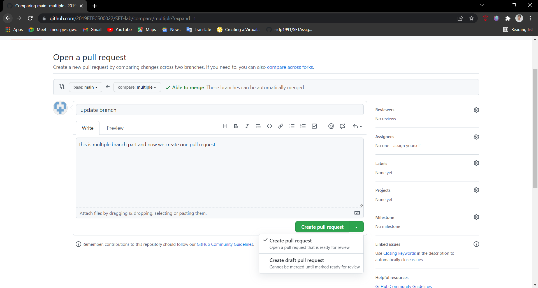

1. Perform merging of both branches

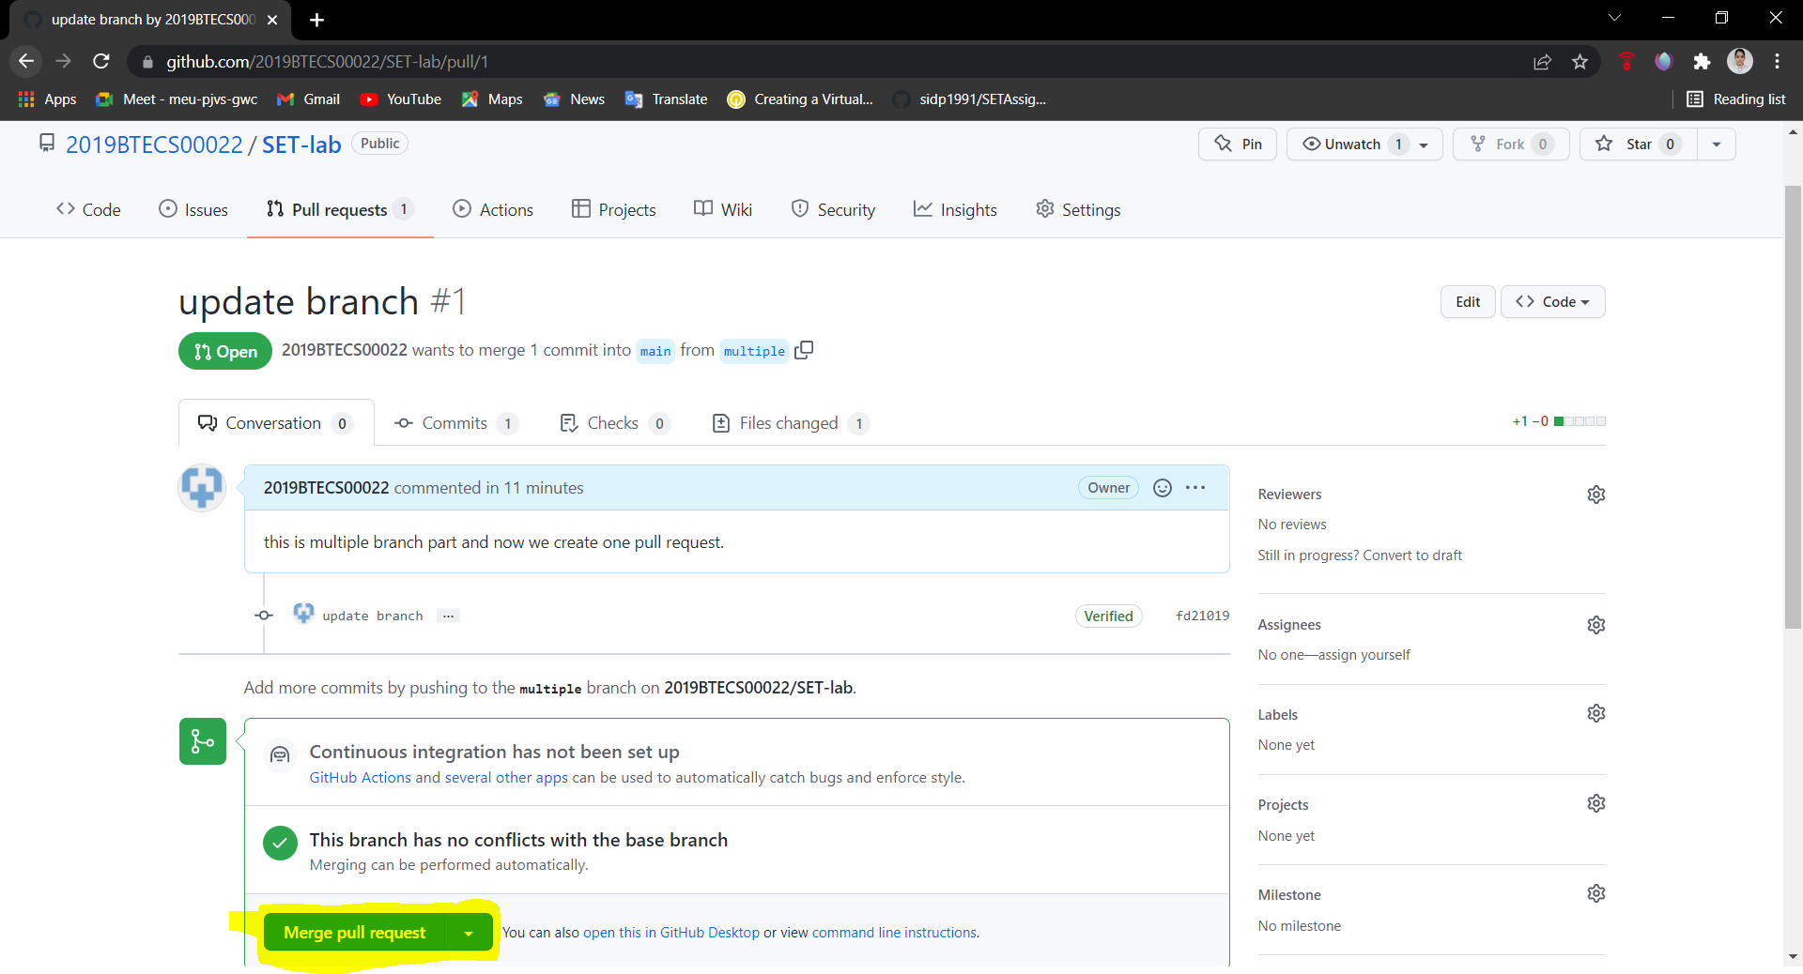

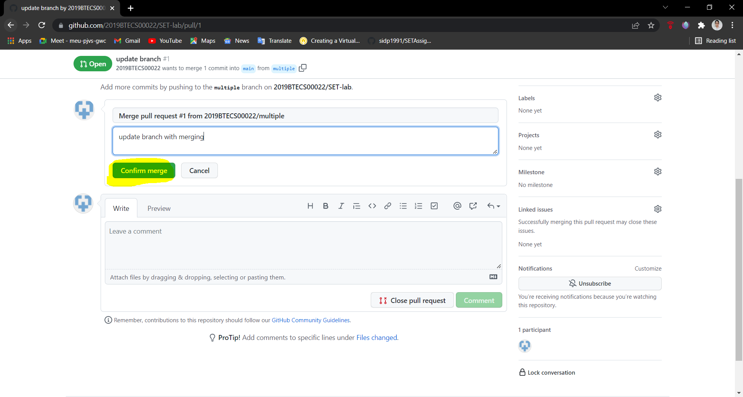

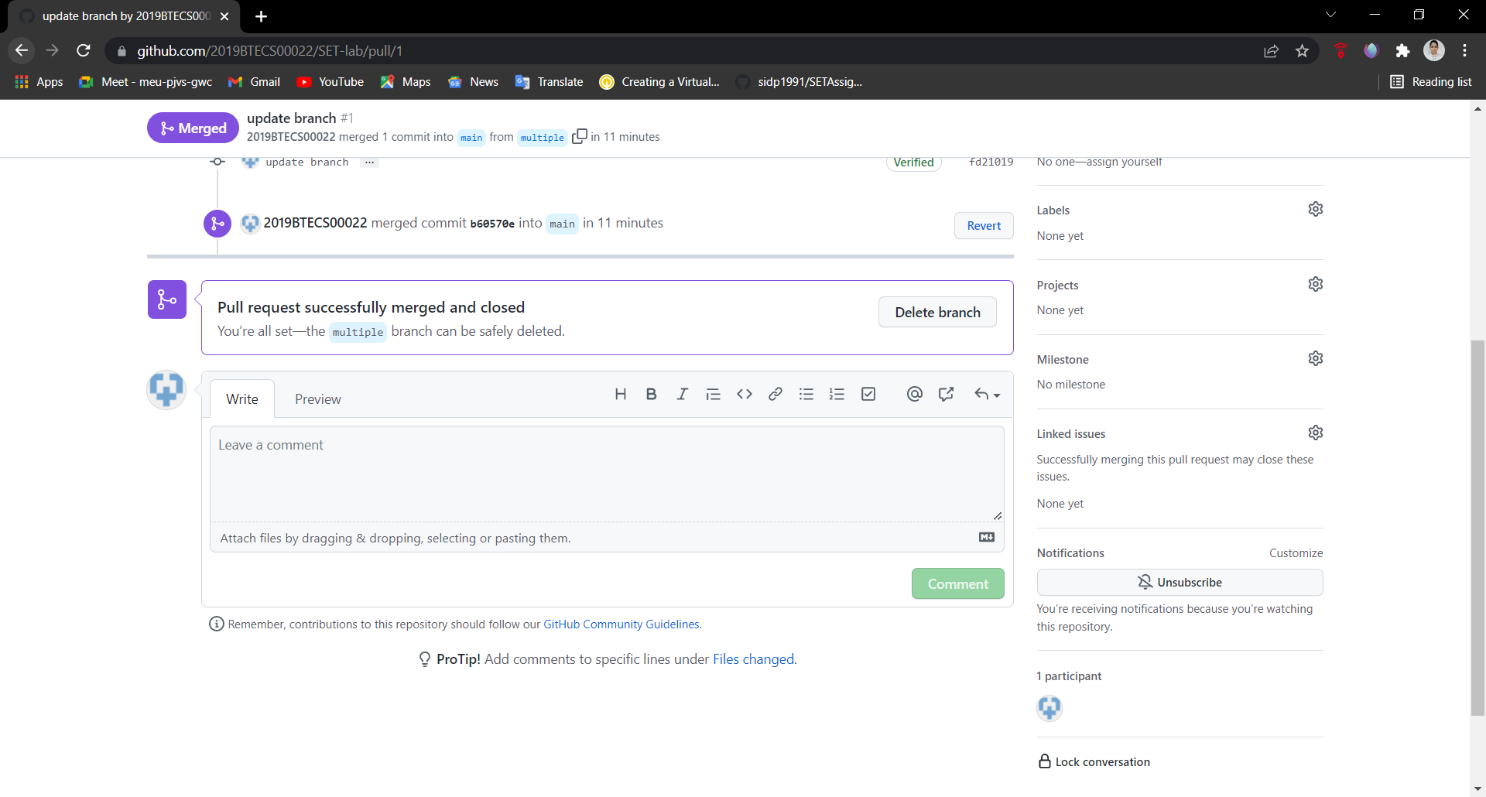

1. Perform Fork operation

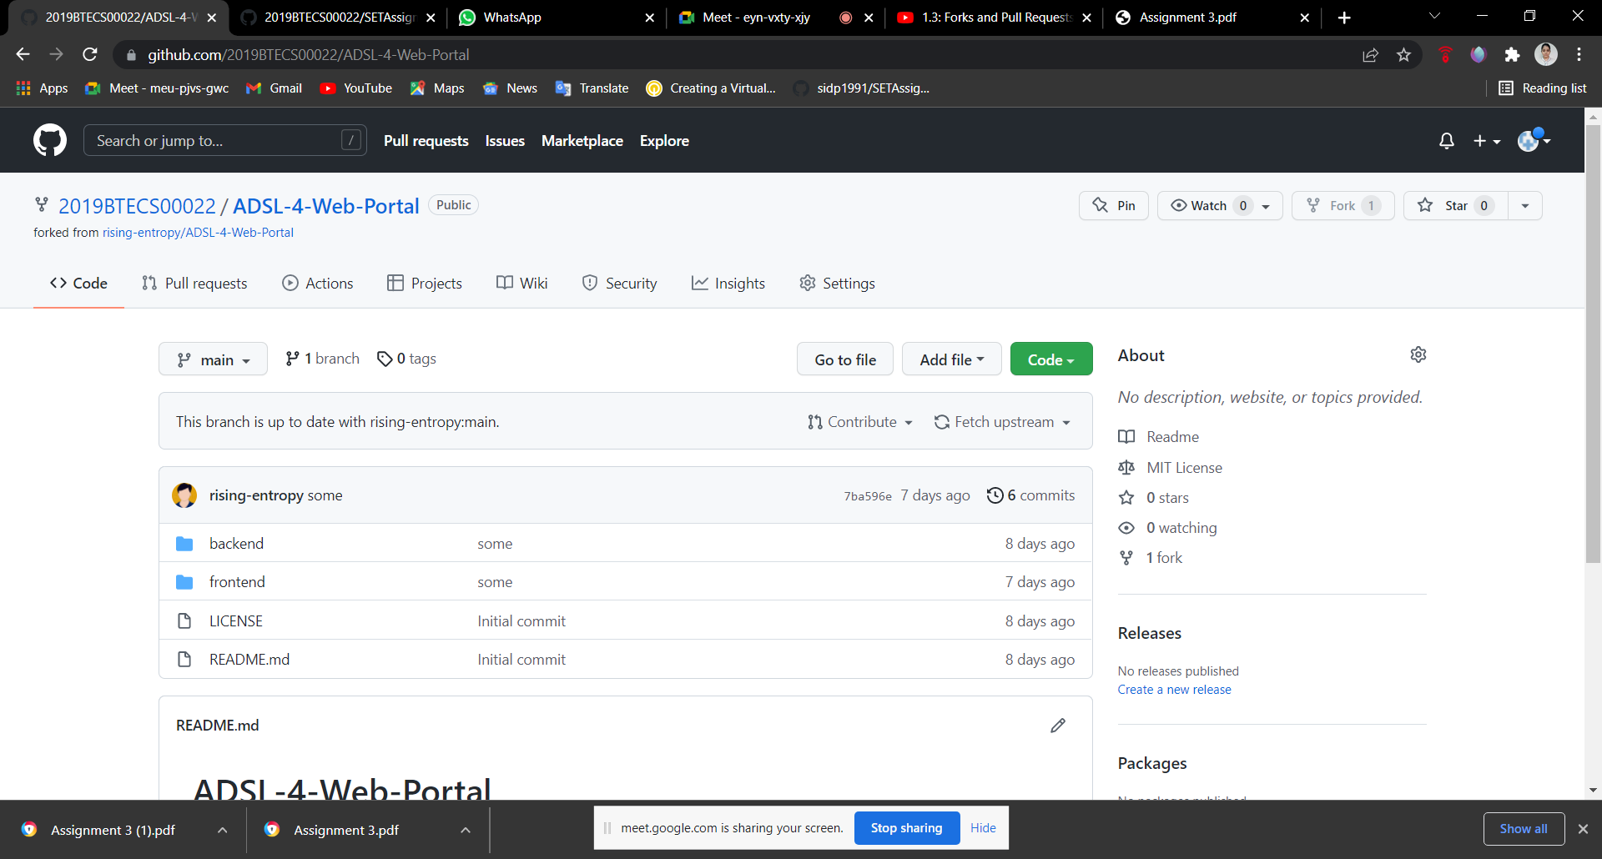

Q 2. For the diagram given below create a GitHub repository and perform operations given in the diagram. (Perform commit operations as given)(Add screenshots as an answer to this question)

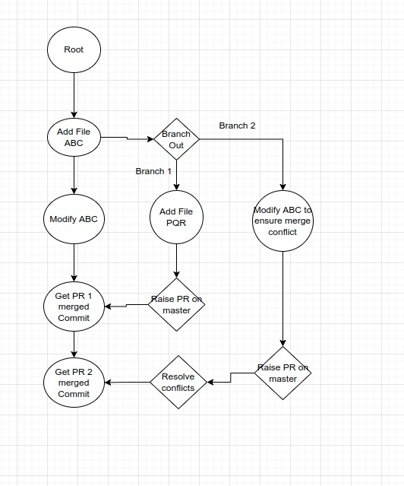

Here, we are used same file as add in Q1; Create new branch





Merge and pull request with forking











Q 3. What is GitHub desktop? How to install GitHub on local machine? Install GitHub on your local machine and access repository created in question no 1 (add screenshots).

Solution: **GitHub Desktop** is an application that enables you to interact with GitHub using a GUI instead of the command line or a web browser. GitHub Desktop encourages you and your team to collaborate using best practices with Git and GitHub. You can use GitHub Desktop to complete most Git commands from your desktop with visual confirmation of changes. You can push to, pull from, and clone remote repositories with GitHub Desktop, and use collaborative tools such as attributing commits and creating pull requests.

I am already install Github desktop in my PC. So, I use some basic Screenshots using web browser.

1. **Is important to have GitHub account first.**

Visit the following site for download GitHub Desktop software for 64bit windows system: <https://desktop.github.com/>

1. Click on download button and after download you will be see GitHub desktop setup.

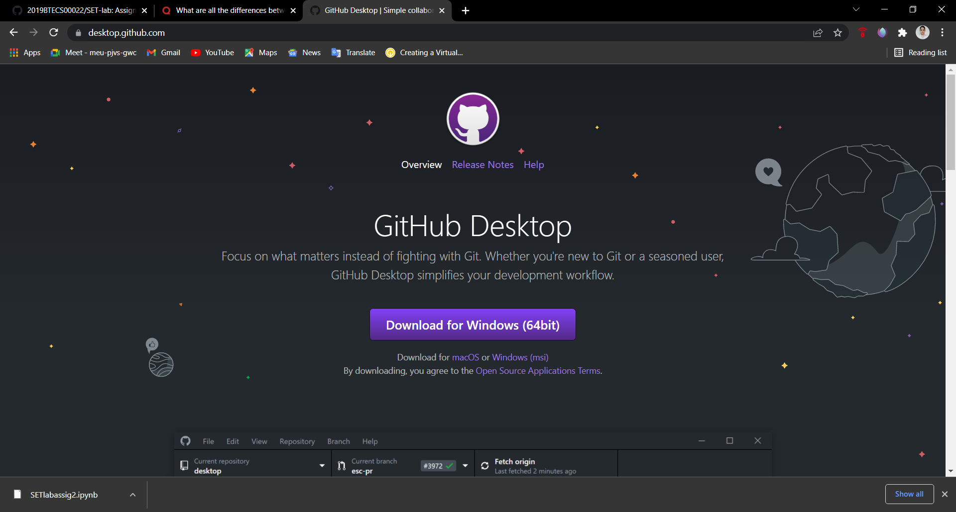

1. GitHub Desktop will launch after installation is complete.
2. This is the home page of GitHub Desktop

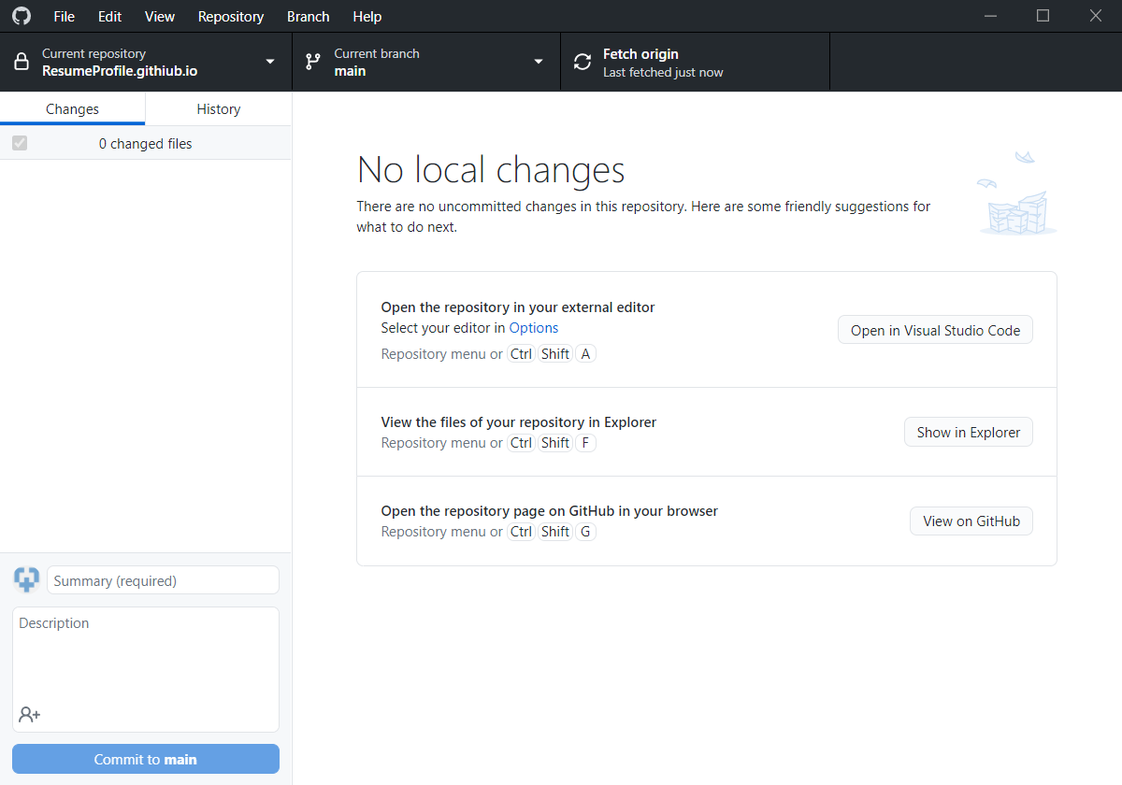

Now, I am going to access repository created in question no 1

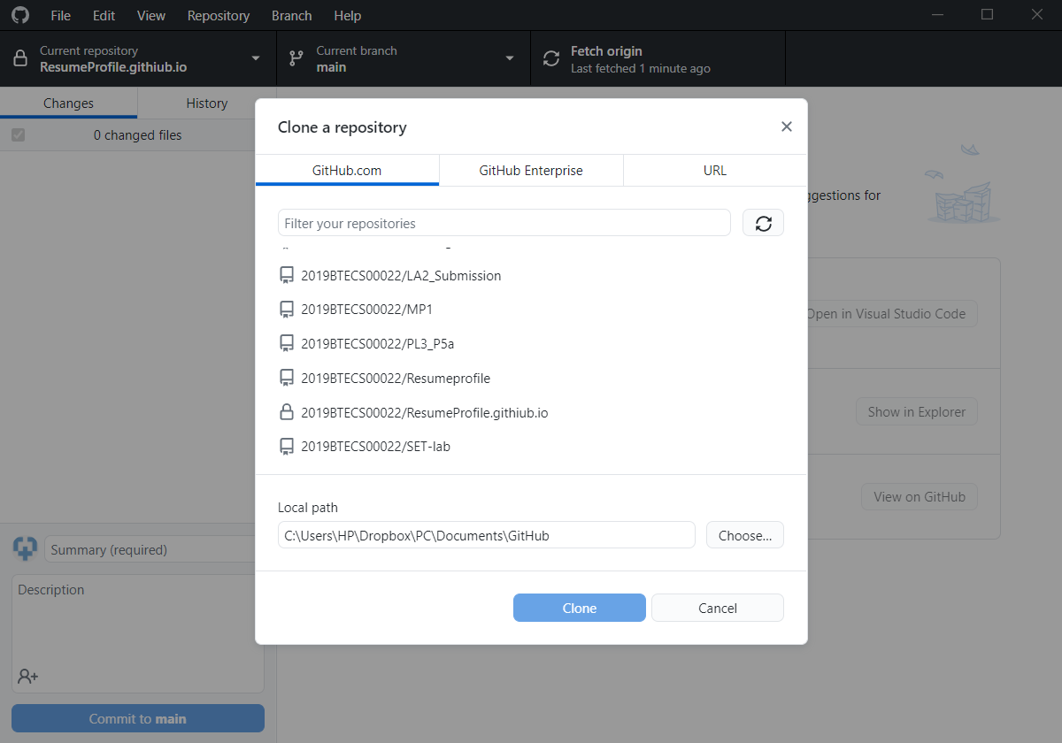

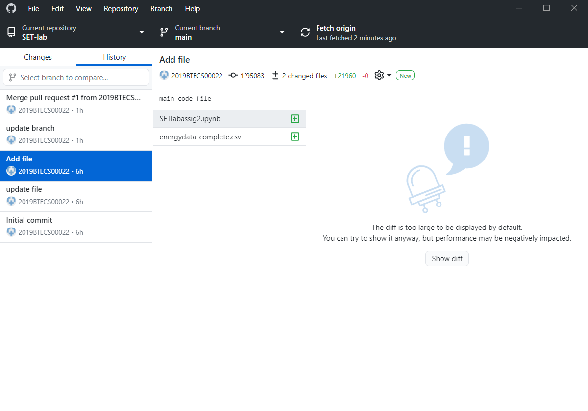

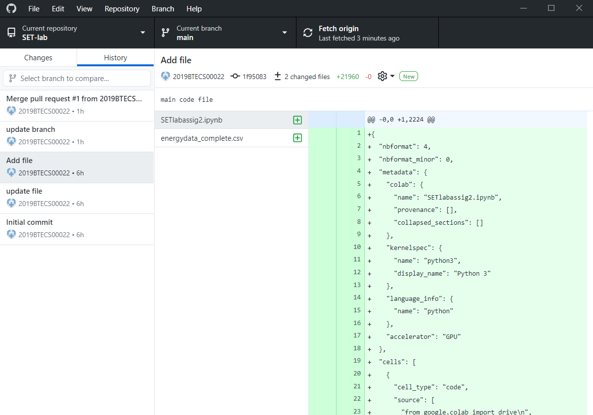

Q 4. Differentiate in between GitHub, Git and GitLab.

Solution:

**GitHub:** GitHub is a cloud-based git repository hosting service. Here, you can manage and share your code with other and manage development teams as collaborators. You can manage private repositories with 3 collaborators for a software development projects.

**Git:** Git is a open source distributed version control system designed to handle everything from small to very large projects with speed and efficiancy. It will manage and keep tacks your changes of your projects. It has a command line and GUI tool for pushing , committing the projects to the github, bitbucket or gitlab.

**Git Lab:**Git lab is a web-based develops life cycle tool provides a git repository manager provides wiki, issue tracking and CI/CD pipe line.

In given tools what we give:

**Authentication Levels:** Git lab having features like adding and modifying people’s permissions according to their roles.

**Built-in CI/CD tool:**GitLab having the feature like automatically testing with CI/CD and no need of humans. It also integrates with external integration applications like jenkins, etc…

And We found some similar features are in gitHub and git lab that is,

**1.Issue Tracking:**Both are connected with visual bug tracker which users, tester, developers and clients also report their bugs through the bug tracker widget.

**2. Integration with external CI/CD tools:**Both are having integration with external CI/CD tools like jenkins , etc…

Q 5. Go to this <https://github.com/sidp1991/SETAssignment>

GitHub repository add your code file (question no 2 solved in assignment no 2) in this repository, then open file [Student assignment updates.txt](https://github.com/sidp1991/SETAssignment/blob/main/Student%20assignment%20updates.txt) present in above repository and update your details such as Name and PRN and then perform commit( need to create pull request with appropriate comments). (Attach screenshots of this activity)

**Solution:**

**First go to the given repository and add file.**

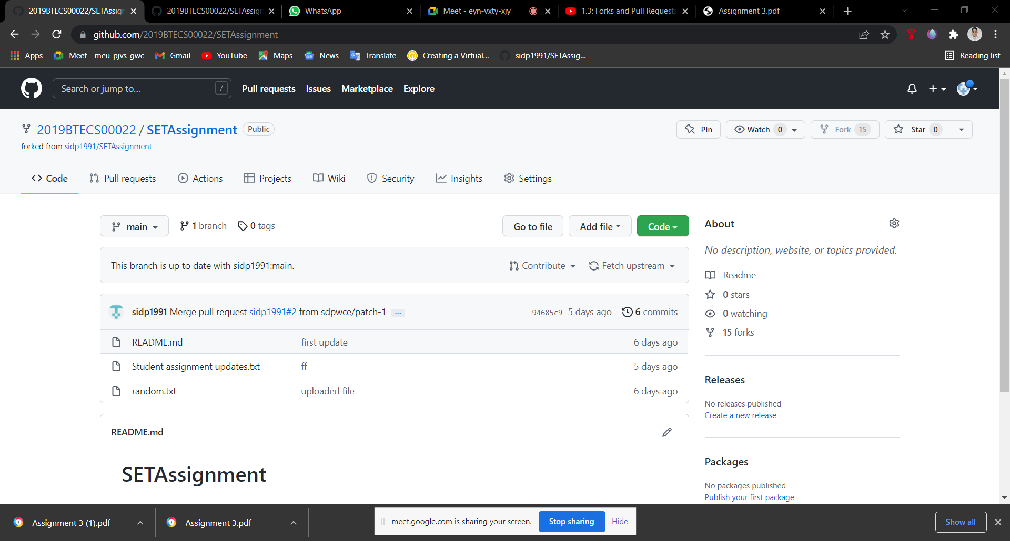

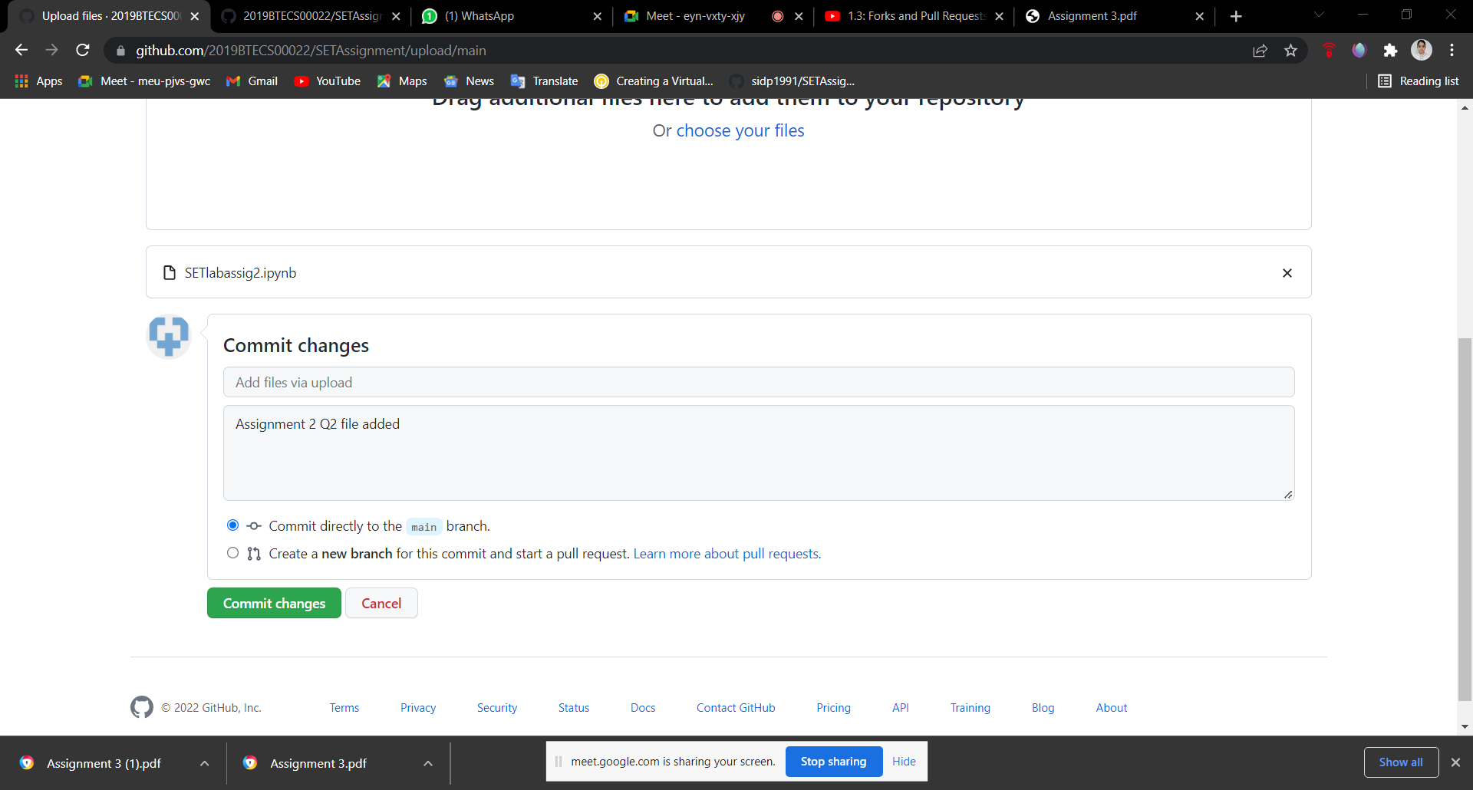

**Write our PRN no and name in given file**

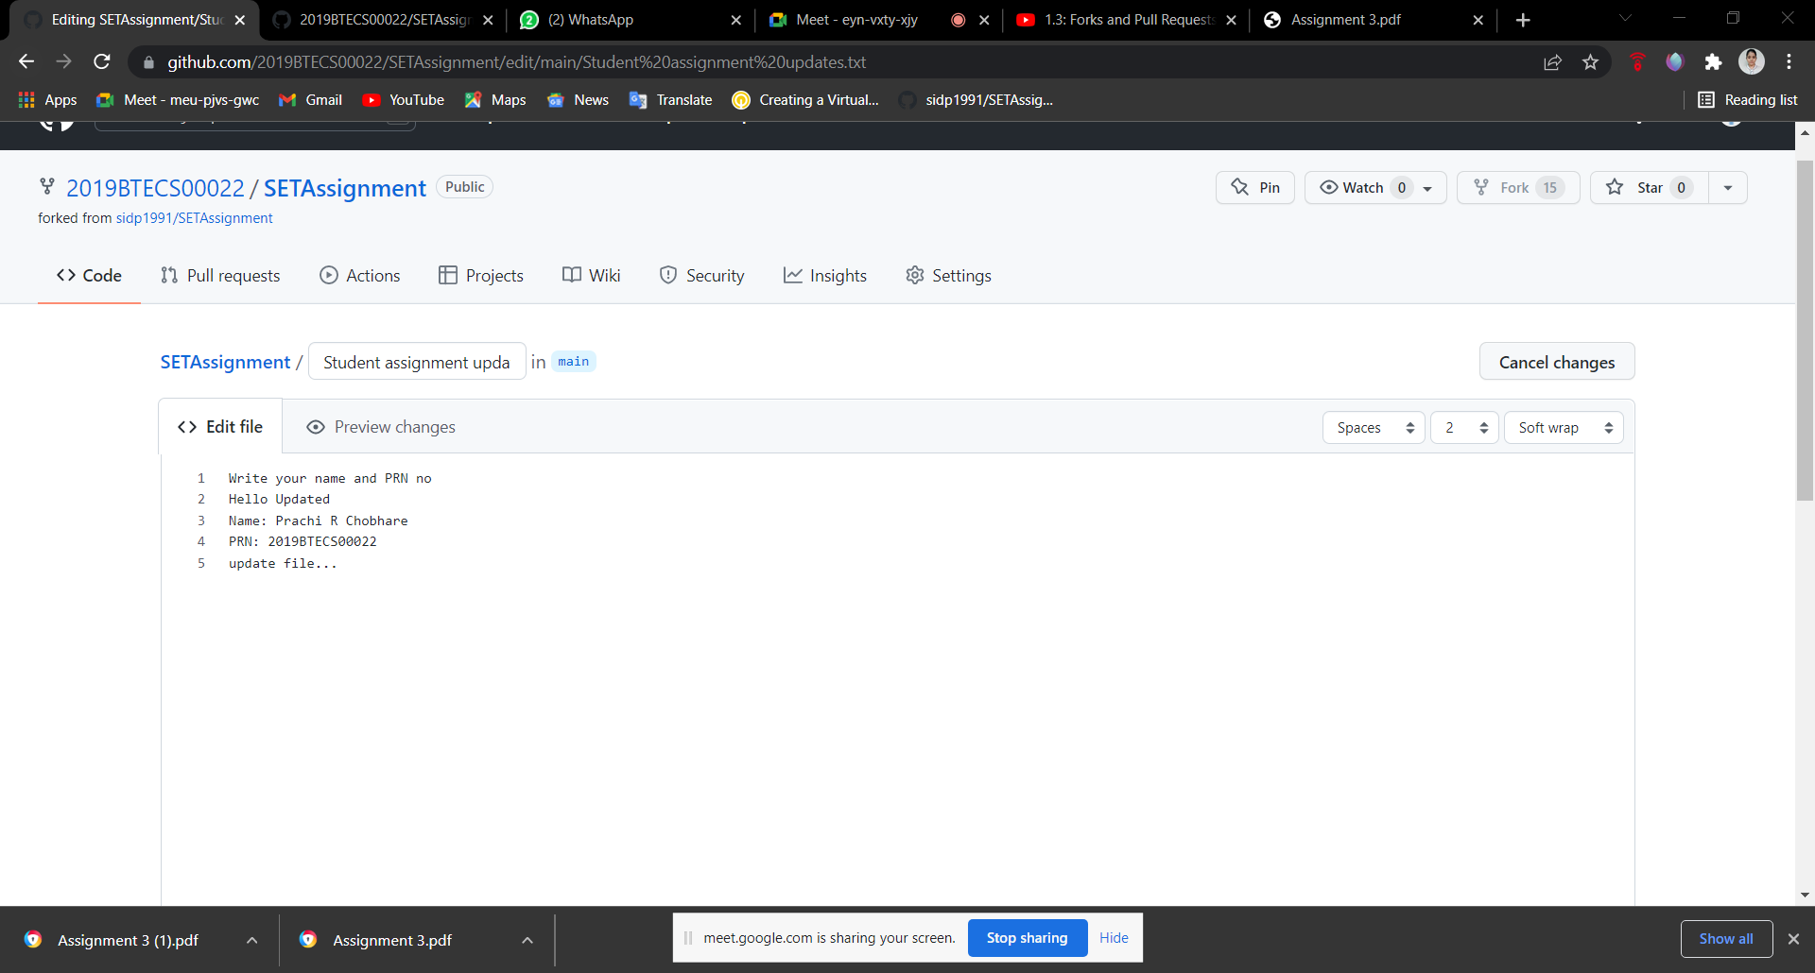

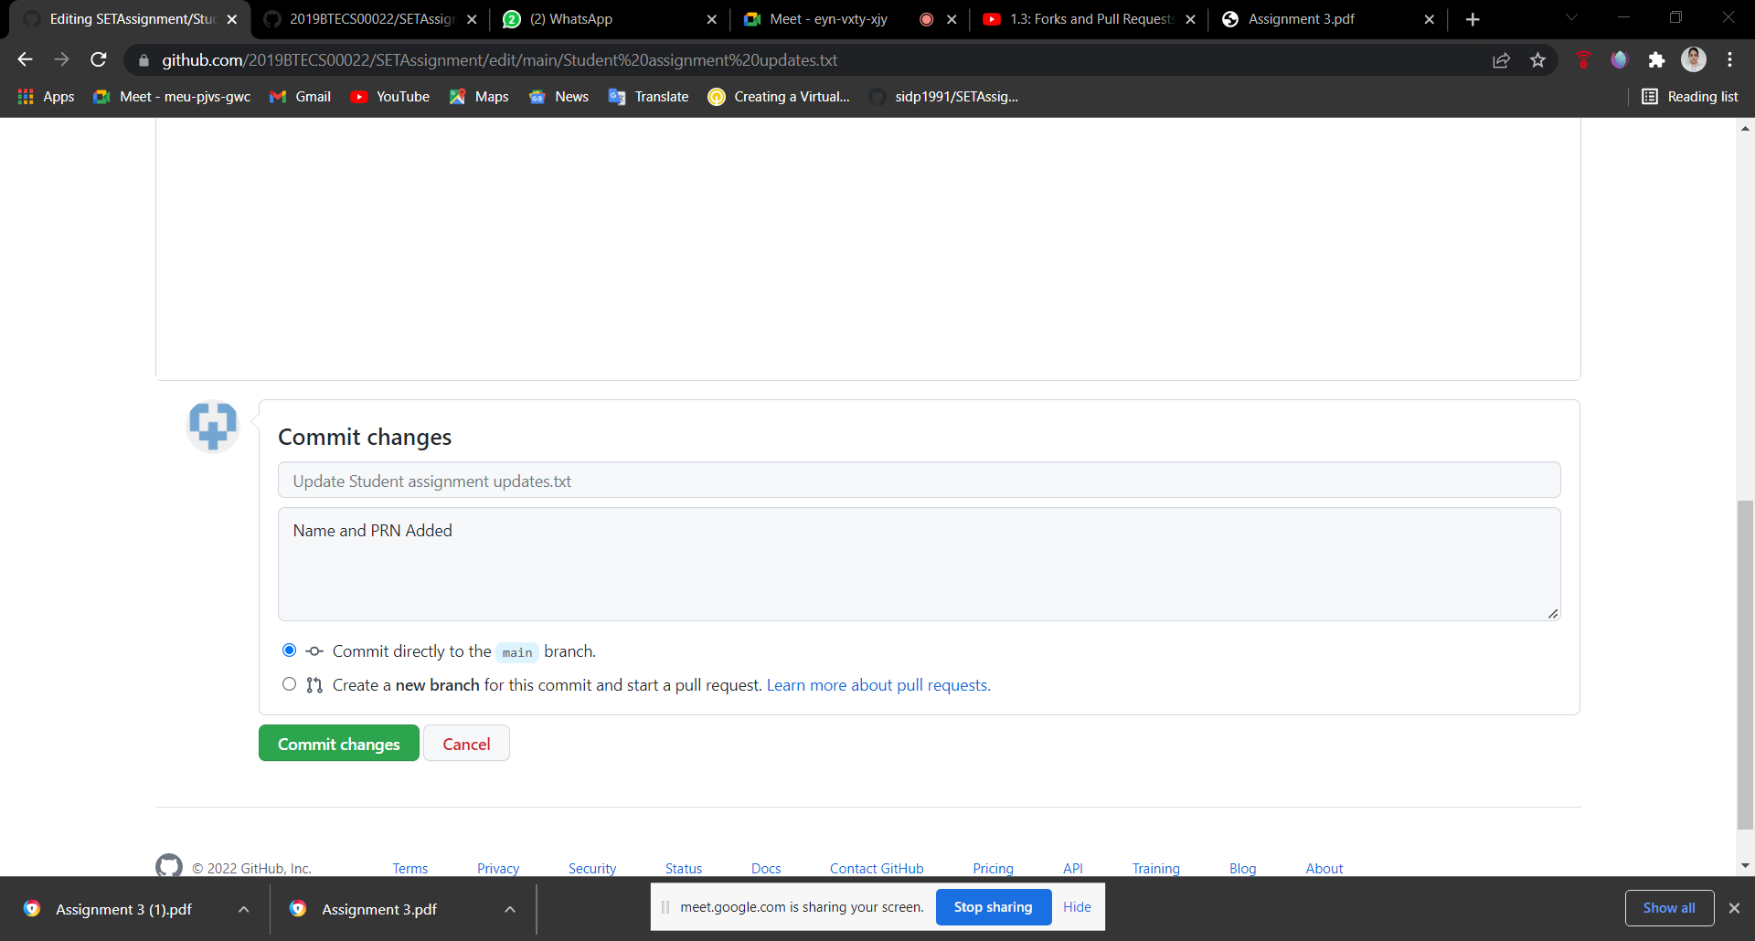

**Create pull request in this repository.**



